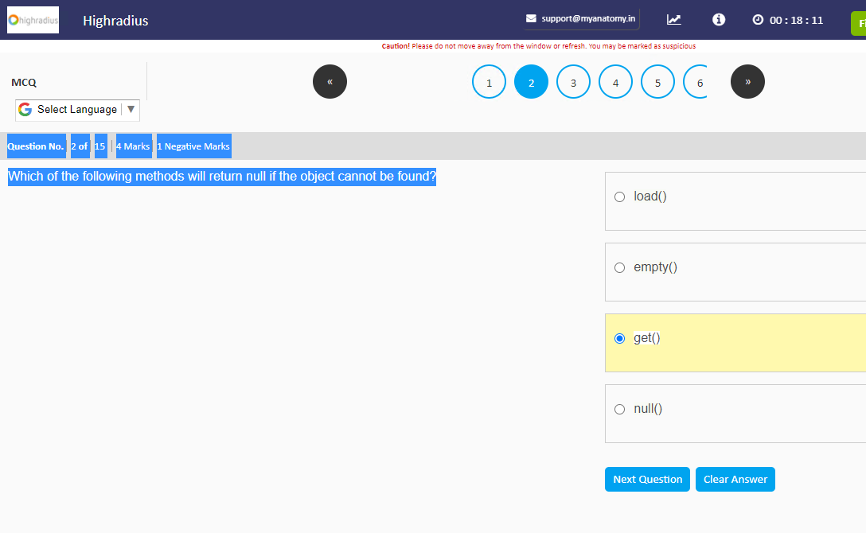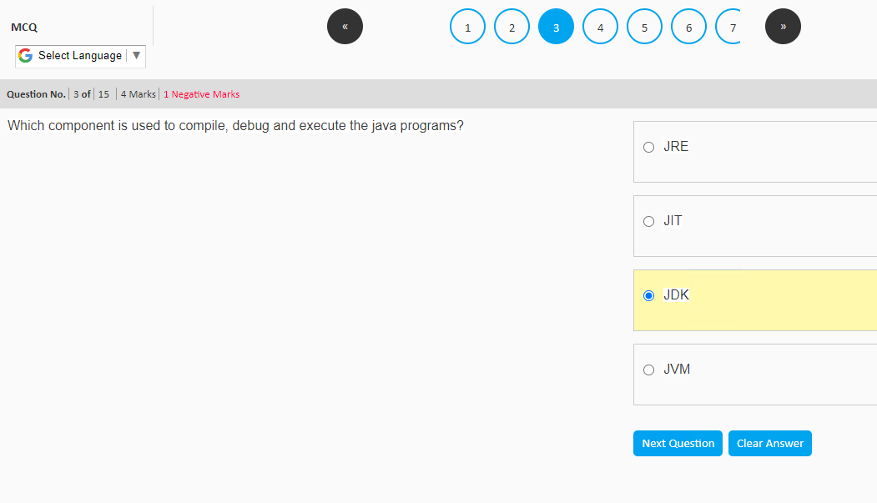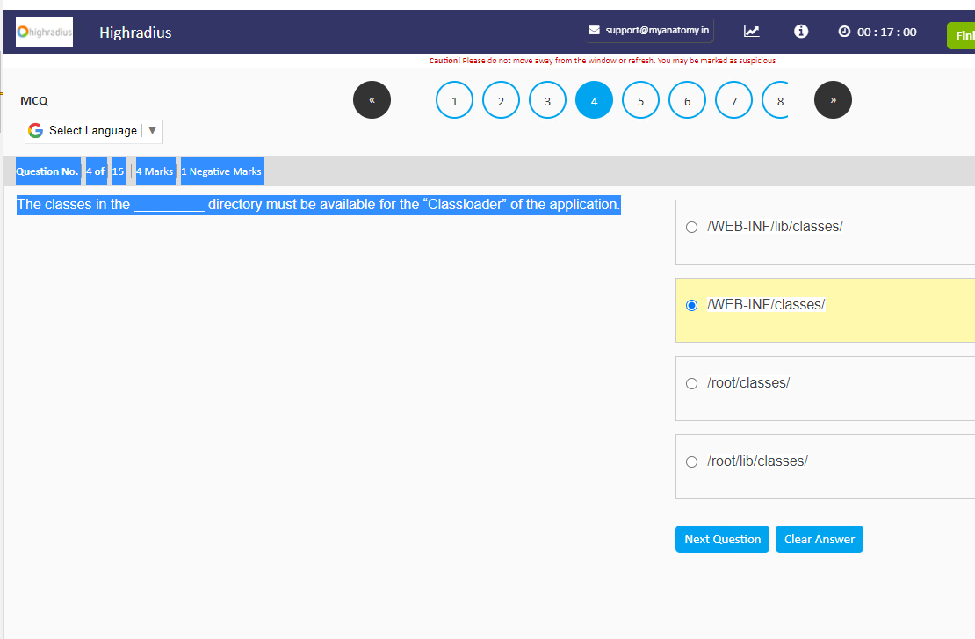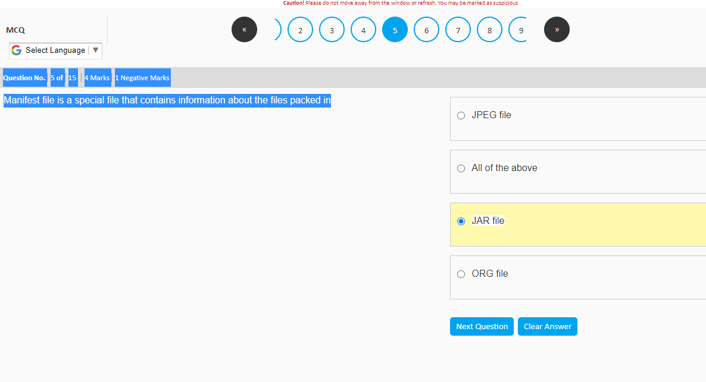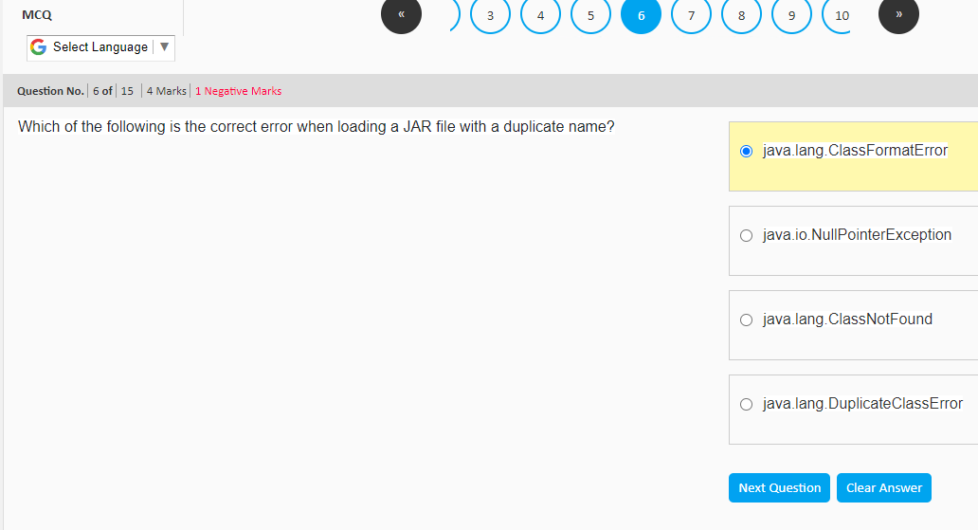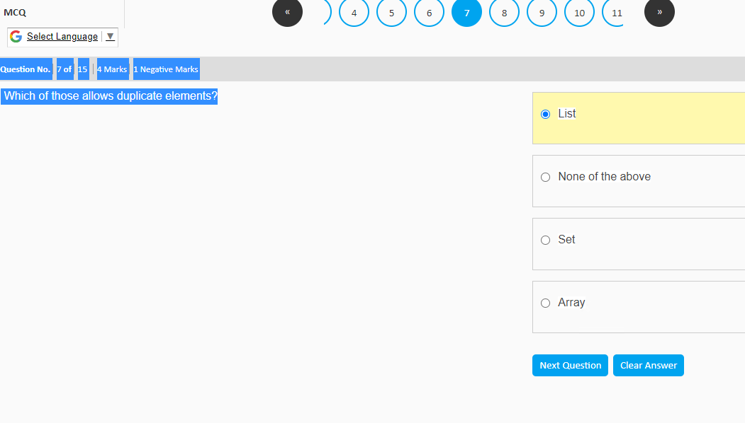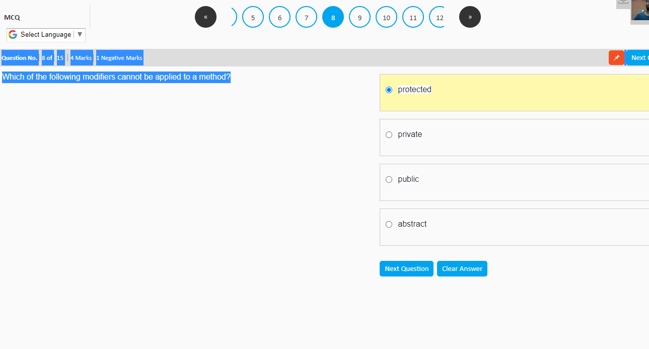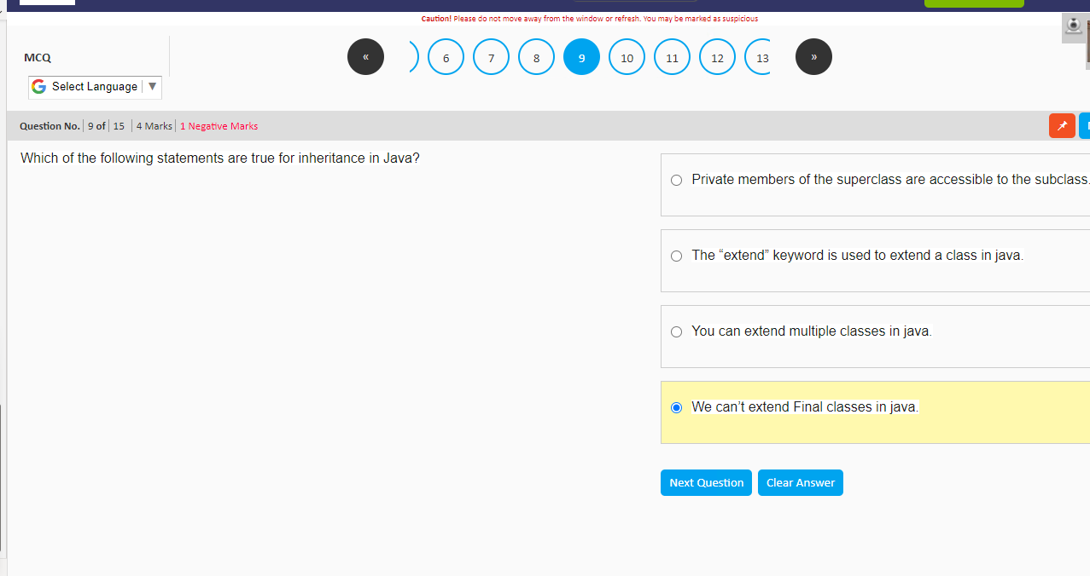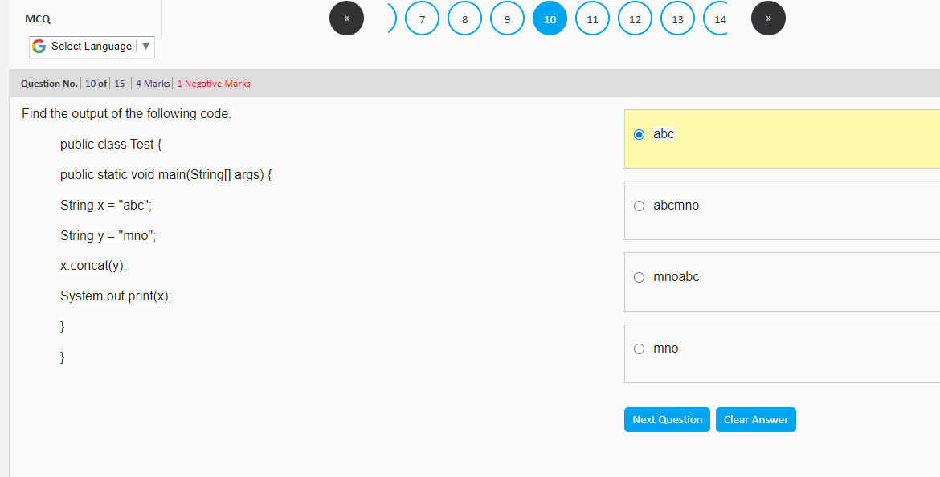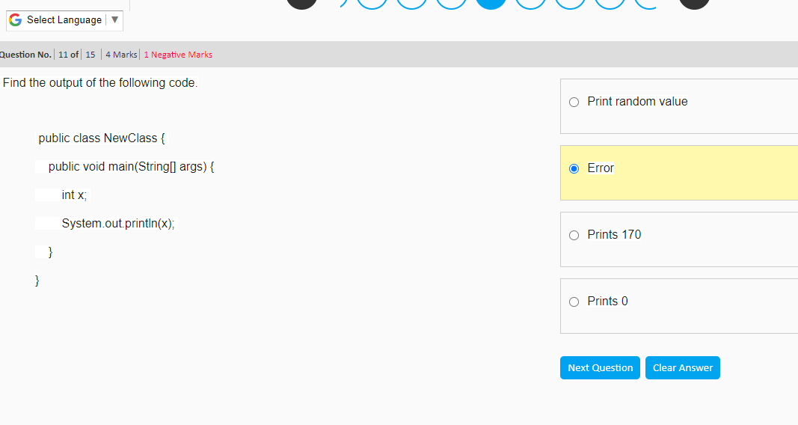

package nonservlet;  
  
import java.util.ArrayList;  
  
import java.util.List;  
  
  
public class Main {  
  
 public static void main(String args[]) {  
  
 List<String> arrayList = new ArrayList<String>();  
  
  
 arrayList.add("p");  
  
 arrayList.add("q");  
  
 arrayList.add("r");  
  
  
 System.*out*.println();  
  
 arrayList.add(1, "s");  
  
 System.*out*.println(arrayList);  
  
 }  
  
}  
  
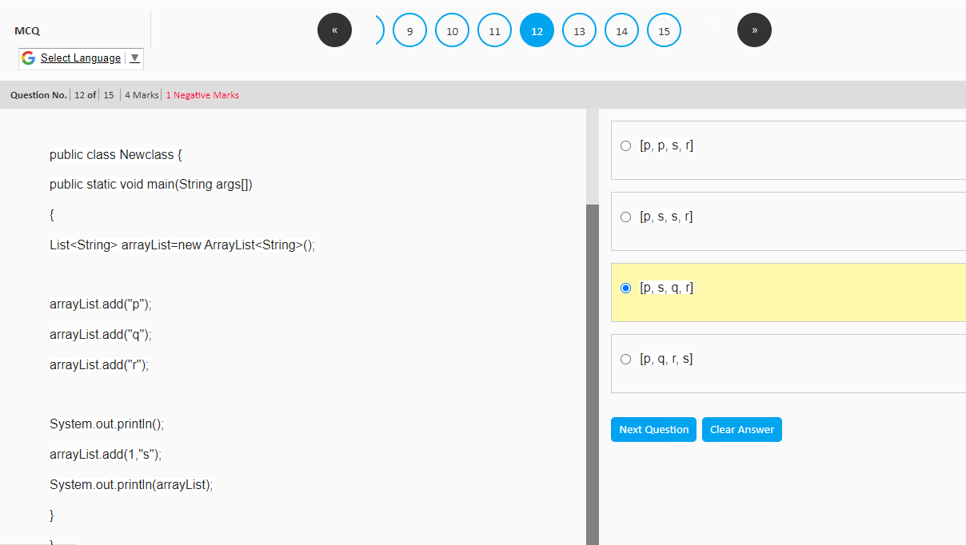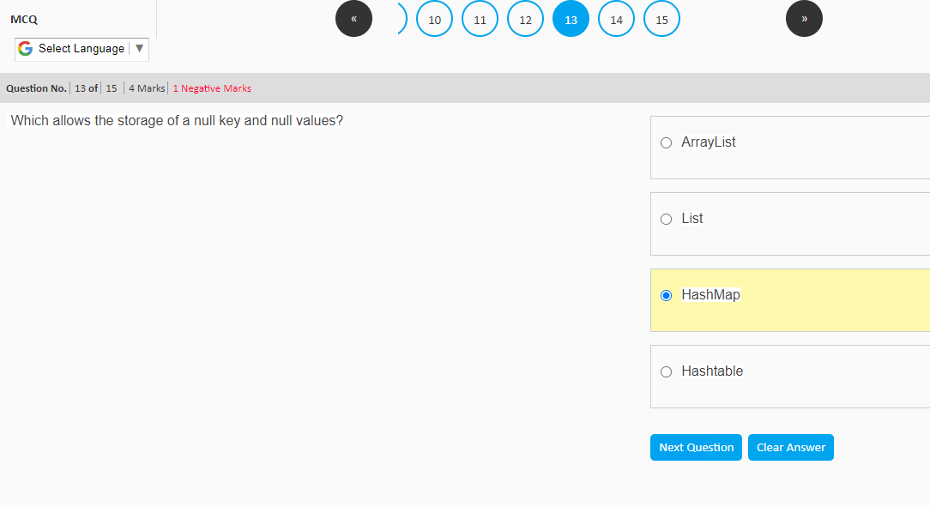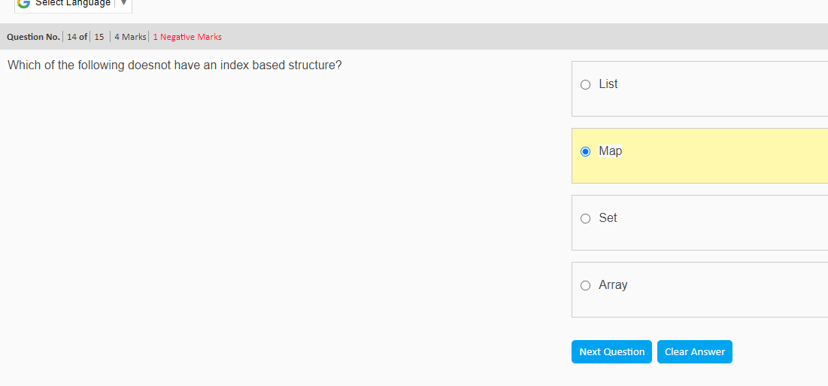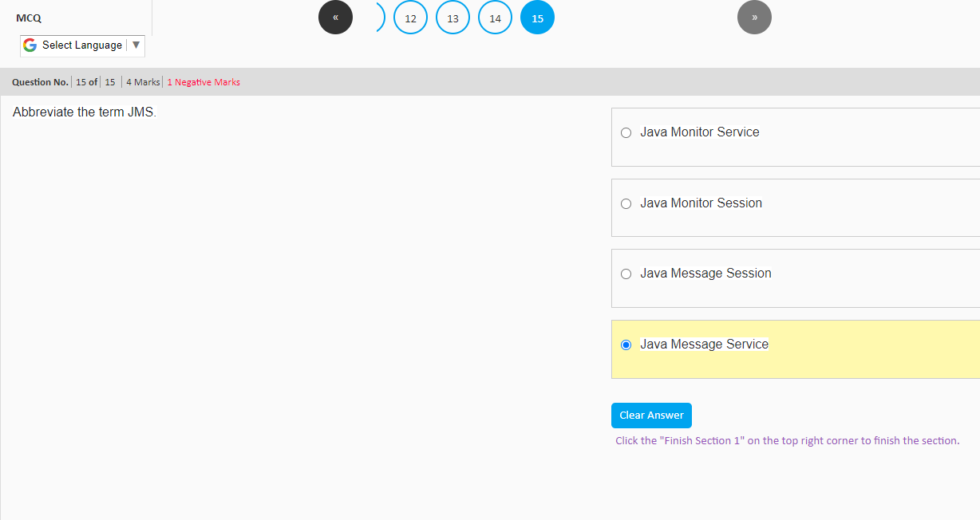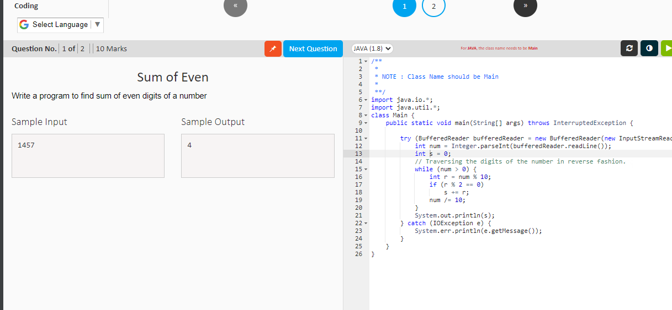

import java.io.BufferedReader;  
import java.io.IOException;  
import java.io.InputStreamReader;  
  
public class Main {  
 public static void main(String[] args) {  
  
 try (BufferedReader bufferedReader = new BufferedReader(new InputStreamReader(System.*in*))) {  
 int num = Integer.*parseInt*(bufferedReader.readLine());  
 int s = 0;  
 // Traversing the digits of the number in reverse fashion.  
 while (num > 0) {  
 int r = num % 10;  
 if (r % 2 == 0)  
 s += r;  
 num /= 10;  
 }  
 System.*out*.println(s);  
 } catch (IOException e) {  
 System.*err*.println(e.getMessage());  
 }  
 }  
}

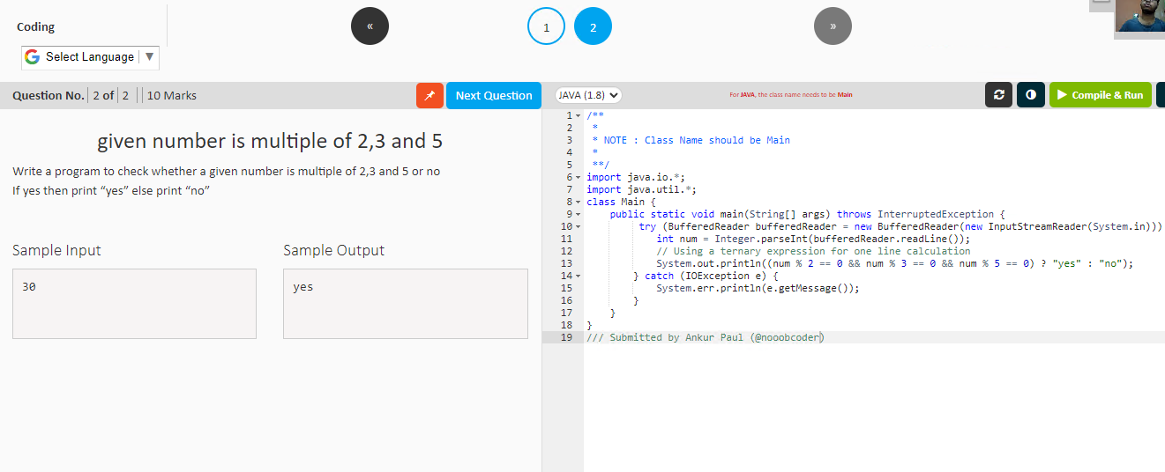

import java.io.BufferedReader;  
import java.io.IOException;  
import java.io.InputStreamReader;  
  
public class Main {  
 public static void main(String[] args) {  
 try (BufferedReader bufferedReader = new BufferedReader(new InputStreamReader(System.*in*))) {  
 int num = Integer.*parseInt*(bufferedReader.readLine());  
 // Using a ternary expression for one line calculation  
 System.*out*.println((num % 2 == 0 && num % 3 == 0 && num % 5 == 0) ? "yes" : "no");  
 } catch (IOException e) {  
 System.*err*.println(e.getMessage());  
 }  
 }  
}